

**20CYS404**

**Android Application Development**

Lab Exam

Course Registration App

**Name :** CH.KRISHNA DHEERAJ

**Roll No :** CH.EN.U4CYS21012

**Experiment Number : Lab Exam - 02**

**Aim:**

to develop a Course Registration App that allows users to add, view, edit, and delete course details using SQLite for local storage and Firebase for cloud sync. The app will feature a simple, user-friendly interface for managing course registrations efficiently.

**Code:**

**File :** MainActivity.java (Registration Page)

package com.example.courseregapp;  
  
import androidx.appcompat.app.AppCompatActivity;  
import android.content.ContentValues;  
import android.database.Cursor;  
import android.database.sqlite.SQLiteDatabase;  
import android.os.Bundle;  
import android.view.View;  
import android.widget.Button;  
import android.widget.EditText;  
import android.widget.Toast;  
import android.widget.ListView;  
import android.widget.AdapterView;  
import android.widget.SimpleCursorAdapter;  
  
public class MainActivity extends AppCompatActivity {  
  
 EditText editName, editCourse, editFee;  
 Button btnAdd, btnView, btnEdit, btnDelete, btnBack;  
 SQLiteDatabase db;  
 DBHelper dbHelper;  
 ListView listView;  
 long selectedId = -1; // Initially, no row is selected for edit or delete  
  
 @Override  
 protected void onCreate(Bundle savedInstanceState) {  
 super.onCreate(savedInstanceState);  
 setContentView(R.layout.*activity_main*);  
  
 // Initialize UI elements  
 editName = findViewById(R.id.*editName*);  
 editCourse = findViewById(R.id.*editCourse*);  
 editFee = findViewById(R.id.*editFee*);  
 btnAdd = findViewById(R.id.*btnAdd*);  
 btnView = findViewById(R.id.*btnView*);  
 btnEdit = findViewById(R.id.*btnEdit*);  
 btnDelete = findViewById(R.id.*btnDelete*);  
 btnBack = findViewById(R.id.*btnBack*);  
 listView = findViewById(R.id.*listView*);  
  
 // Initialize SQLite DB  
 dbHelper = new DBHelper(this);  
 db = dbHelper.getWritableDatabase();  
  
 btnAdd.setOnClickListener(new View.OnClickListener() {  
 @Override  
 public void onClick(View v) {  
 addRecord();  
 }  
 });  
  
 btnView.setOnClickListener(new View.OnClickListener() {  
 @Override  
 public void onClick(View v) {  
 viewRecords();  
 }  
 });  
  
 btnEdit.setOnClickListener(new View.OnClickListener() {  
 @Override  
 public void onClick(View v) {  
 editRecord();  
 }  
 });  
  
 btnDelete.setOnClickListener(new View.OnClickListener() {  
 @Override  
 public void onClick(View v) {  
 deleteRecord();  
 }  
 });  
  
 btnBack.setOnClickListener(new View.OnClickListener() {  
 @Override  
 public void onClick(View v) {  
 clearFields();  
 }  
 });  
  
 // Handling row click to select for edit or delete  
 listView.setOnItemClickListener(new AdapterView.OnItemClickListener() {  
 @Override  
 public void onItemClick(AdapterView<?> parent, View view, int position, long id) {  
 Cursor cursor = (Cursor) listView.getItemAtPosition(position);  
 selectedId = cursor.getLong(cursor.getColumnIndexOrThrow("_id"));  
  
 editName.setText(cursor.getString(cursor.getColumnIndexOrThrow("name")));  
 editCourse.setText(cursor.getString(cursor.getColumnIndexOrThrow("course")));  
 editFee.setText(cursor.getString(cursor.getColumnIndexOrThrow("fee")));  
 }  
 });  
 }  
  
 // Method to add new record  
 private void addRecord() {  
 ContentValues values = new ContentValues();  
 values.put("name", editName.getText().toString());  
 values.put("course", editCourse.getText().toString());  
 values.put("fee", editFee.getText().toString());  
  
 long newRowId = db.insert("registration", null, values);  
  
 if (newRowId != -1) {  
 Toast.*makeText*(MainActivity.this, "Record Added", Toast.*LENGTH_SHORT*).show();  
 } else {  
 Toast.*makeText*(MainActivity.this, "Error Adding Record", Toast.*LENGTH_SHORT*).show();  
 }  
 clearFields(); // Clear the input fields after adding  
 }  
  
 // Method to view all records  
 private void viewRecords() {  
 Cursor cursor = db.query("registration", null, null, null, null, null, null);  
 String[] from = {"_id", "name", "course", "fee"};  
 int[] to = {R.id.*textId*, R.id.*textName*, R.id.*textCourse*, R.id.*textFee*};  
  
 SimpleCursorAdapter adapter = new SimpleCursorAdapter(this, R.layout.*list_item*, cursor, from, to, 0);  
 listView.setAdapter(adapter);  
 }  
  
 // Method to edit a record  
 private void editRecord() {  
 if (selectedId == -1) {  
 Toast.*makeText*(this, "Select a record first", Toast.*LENGTH_SHORT*).show();  
 return;  
 }  
  
 ContentValues values = new ContentValues();  
 values.put("name", editName.getText().toString());  
 values.put("course", editCourse.getText().toString());  
 values.put("fee", editFee.getText().toString());  
  
 int rowsAffected = db.update("registration", values, "_id = ?", new String[]{String.*valueOf*(selectedId)});  
 if (rowsAffected > 0) {  
 Toast.*makeText*(MainActivity.this, "Record Updated", Toast.*LENGTH_SHORT*).show();  
 } else {  
 Toast.*makeText*(MainActivity.this, "Error Updating Record", Toast.*LENGTH_SHORT*).show();  
 }  
 clearFields(); // Clear the input fields after editing  
 }  
  
 // Method to delete a record  
 private void deleteRecord() {  
 if (selectedId == -1) {  
 Toast.*makeText*(this, "Select a record first", Toast.*LENGTH_SHORT*).show();  
 return;  
 }  
  
 int rowsDeleted = db.delete("registration", "_id = ?", new String[]{String.*valueOf*(selectedId)});  
 if (rowsDeleted > 0) {  
 Toast.*makeText*(MainActivity.this, "Record Deleted", Toast.*LENGTH_SHORT*).show();  
 } else {  
 Toast.*makeText*(MainActivity.this, "Error Deleting Record", Toast.*LENGTH_SHORT*).show();  
 }  
 clearFields(); // Clear the input fields after deleting  
 }  
  
 // Method to clear input fields  
 private void clearFields() {  
 editName.setText("");  
 editCourse.setText("");  
 editFee.setText("");  
 selectedId = -1;  
 }  
}

**File : activity_main.xml**

<?xml version="1.0" encoding="utf-8"?>  
<LinearLayout xmlns:android="http://schemas.android.com/apk/res/android"  
 android:layout_width="match_parent"  
 android:layout_height="match_parent"  
 android:orientation="vertical"  
 android:padding="16dp"  
 android:background="@color/primary_background"  
 android:gravity="center">  
  
 <!-- Title Text -->  
 <TextView  
 android:id="@+id/tvTitle"  
 android:layout_width="wrap_content"  
 android:layout_height="wrap_content"  
 android:text="Course Registration"  
 android:textSize="26sp"  
 android:textStyle="bold"  
 android:textColor="@color/title_text_color"  
 android:layout_marginBottom="24dp"  
 android:gravity="center_horizontal" />  
  
 <!-- Ramcharan 21005 -->  
 <TextView  
 android:id="@+id/tvRamcharanId"  
 android:layout_width="wrap_content"  
 android:layout_height="wrap_content"  
 android:text="Ramcharan 21005"  
 android:textColor="@color/black"  
 android:textStyle="bold"  
 android:textSize="20sp"  
 android:layout_gravity="center"  
 android:layout_marginBottom="20dp"/>  
  
 <!-- Name Input -->  
 <EditText  
 android:id="@+id/editName"  
 android:layout_width="match_parent"  
 android:layout_height="wrap_content"  
 android:hint="Enter Name"  
 android:background="@color/edittext_background"  
 android:textColor="@color/normal_text_color"  
 android:textColorHint="@color/accent_color"  
 android:layout_marginBottom="16dp"  
 android:padding="12dp"  
 android:layout_marginEnd="16dp"  
 android:layout_marginStart="16dp"  
 android:elevation="4dp"  
 android:textSize="16sp" />  
  
 <!-- Course Input -->  
 <EditText  
 android:id="@+id/editCourse"  
 android:layout_width="match_parent"  
 android:layout_height="wrap_content"  
 android:hint="Enter Course"  
 android:background="@color/edittext_background"  
 android:textColor="@color/normal_text_color"  
 android:textColorHint="@color/accent_color"  
 android:layout_marginBottom="16dp"  
 android:padding="12dp"  
 android:layout_marginEnd="16dp"  
 android:layout_marginStart="16dp"  
 android:elevation="4dp"  
 android:textSize="16sp" />  
  
 <!-- Fee Input -->  
 <EditText  
 android:id="@+id/editFee"  
 android:layout_width="match_parent"  
 android:layout_height="wrap_content"  
 android:hint="Enter Fee"  
 android:background="@color/edittext_background"  
 android:textColor="@color/normal_text_color"  
 android:textColorHint="@color/accent_color"  
 android:inputType="number"  
 android:layout_marginBottom="24dp"  
 android:padding="12dp"  
 android:layout_marginEnd="16dp"  
 android:layout_marginStart="16dp"  
 android:elevation="4dp"  
 android:textSize="16sp" />  
  
 <!-- Add Button -->  
 <Button  
 android:id="@+id/btnAdd"  
 android:layout_width="match_parent"  
 android:layout_height="wrap_content"  
 android:text="Add"  
 android:backgroundTint="@color/button_color"  
 android:textColor="@color/button_text_color"  
 android:layout_marginBottom="12dp"  
 android:layout_marginEnd="16dp"  
 android:layout_marginStart="16dp"  
 android:elevation="6dp" />  
  
 <!-- View Button -->  
 <Button  
 android:id="@+id/btnView"  
 android:layout_width="match_parent"  
 android:layout_height="wrap_content"  
 android:text="View"  
 android:backgroundTint="@color/button_color"  
 android:textColor="@color/button_text_color"  
 android:layout_marginBottom="12dp"  
 android:layout_marginEnd="16dp"  
 android:layout_marginStart="16dp"  
 android:elevation="6dp" />  
  
 <!-- ListView for displaying records -->  
 <ListView  
 android:id="@+id/listView"  
 android:layout_width="match_parent"  
 android:layout_height="0dp"  
 android:layout_weight="1"  
 android:divider="@color/listview_divider"  
 android:dividerHeight="2dp"  
 android:background="@color/secondary_background"  
 android:layout_marginBottom="24dp"  
 android:layout_marginEnd="16dp"  
 android:layout_marginStart="16dp"  
 android:elevation="2dp"/>  
  
 <!-- Edit and Delete Buttons -->  
 <LinearLayout  
 android:layout_width="match_parent"  
 android:layout_height="wrap_content"  
 android:orientation="horizontal"  
 android:gravity="center"  
 android:layout_marginBottom="16dp">  
  
 <Button  
 android:id="@+id/btnEdit"  
 android:layout_width="0dp"  
 android:layout_height="wrap_content"  
 android:layout_weight="1"  
 android:text="Edit"  
 android:backgroundTint="@color/button_color"  
 android:textColor="@color/button_text_color"  
 android:layout_marginEnd="8dp"  
 android:elevation="6dp" />  
  
 <Button  
 android:id="@+id/btnDelete"  
 android:layout_width="0dp"  
 android:layout_height="wrap_content"  
 android:layout_weight="1"  
 android:text="Delete"  
 android:backgroundTint="@color/button_color"  
 android:textColor="@color/button_text_color"  
 android:elevation="6dp" />  
 </LinearLayout>  
  
 <!-- Back Button -->  
 <Button  
 android:id="@+id/btnBack"  
 android:layout_width="match_parent"  
 android:layout_height="wrap_content"  
 android:text="Back"  
 android:backgroundTint="@color/button_color"  
 android:textColor="@color/button_text_color"  
 android:layout_marginEnd="16dp"  
 android:layout_marginStart="16dp"  
 android:elevation="6dp" />  
  
</LinearLayout>

**File : DBHelper.java**

package com.example.courseregapp;  
  
import android.content.Context;  
import android.database.sqlite.SQLiteDatabase;  
import android.database.sqlite.SQLiteOpenHelper;  
  
public class DBHelper extends SQLiteOpenHelper {  
  
 private static final String *DATABASE_NAME* = "registration.db";  
 private static final int *DATABASE_VERSION* = 1;  
  
 public DBHelper(Context context) {  
 super(context, *DATABASE_NAME*, null, *DATABASE_VERSION*);  
 }  
  
 @Override  
 public void onCreate(SQLiteDatabase db) {  
 db.execSQL("CREATE TABLE registration (_id INTEGER PRIMARY KEY AUTOINCREMENT, name TEXT, course TEXT, fee TEXT)");  
 }  
  
 @Override  
 public void onUpgrade(SQLiteDatabase db, int oldVersion, int newVersion) {  
 db.execSQL("DROP TABLE IF EXISTS registration");  
 onCreate(db);  
 }  
}

**File : list_item.xml**

<?xml version="1.0" encoding="utf-8"?>  
<LinearLayout xmlns:android="http://schemas.android.com/apk/res/android"  
 android:layout_width="match_parent"  
 android:layout_height="wrap_content"  
 android:orientation="vertical"  
 android:padding="10dp"  
 android:background="#C19D9D"  
 android:layout_marginBottom="8dp"  
 android:elevation="2dp">  
  
 <TextView  
 android:id="@+id/textId"  
 android:layout_width="wrap_content"  
 android:layout_height="wrap_content"  
 android:text="ID"  
 android:textColor="#3D141313"  
 android:textSize="12sp"  
 android:layout_marginBottom="4dp" />  
  
 <TextView  
 android:id="@+id/textName"  
 android:layout_width="wrap_content"  
 android:layout_height="wrap_content"  
 android:text="Name"  
 android:textColor="@android:color/black"  
 android:textSize="18sp"  
 android:fontFamily="sans-serif-medium"  
 android:layout_marginBottom="2dp" />  
  
 <TextView  
 android:id="@+id/textCourse"  
 android:layout_width="wrap_content"  
 android:layout_height="wrap_content"  
 android:text="Course"  
 android:textColor="@android:color/black"  
 android:textSize="16sp"  
 android:layout_marginBottom="2dp" />  
  
 <TextView  
 android:id="@+id/textFee"  
 android:layout_width="wrap_content"  
 android:layout_height="wrap_content"  
 android:text="Fee"  
 android:textColor="@android:color/black"  
 android:textSize="16sp" />  
  
</LinearLayout>

**File : AndroidManifest.xml**

<?xml version="1.0" encoding="utf-8"?>  
<manifest xmlns:android="http://schemas.android.com/apk/res/android"  
 xmlns:tools="http://schemas.android.com/tools">  
  
 <application  
 android:allowBackup="true"  
 android:dataExtractionRules="@xml/data_extraction_rules"  
 android:fullBackupContent="@xml/backup_rules"  
 android:icon="@mipmap/ic_launcher"  
 android:label="@string/app_name"  
 android:roundIcon="@mipmap/ic_launcher_round"  
 android:supportsRtl="true"  
 android:theme="@style/Theme.Registration"  
 tools:targetApi="31">  
 <activity  
 android:name=".MainActivity"  
 android:exported="true">  
 <intent-filter>  
 <action android:name="android.intent.action.MAIN" />  
  
 <category android:name="android.intent.category.LAUNCHER" />  
 </intent-filter>  
 </activity>  
 </application>  
  
</manifest>

**Output:**

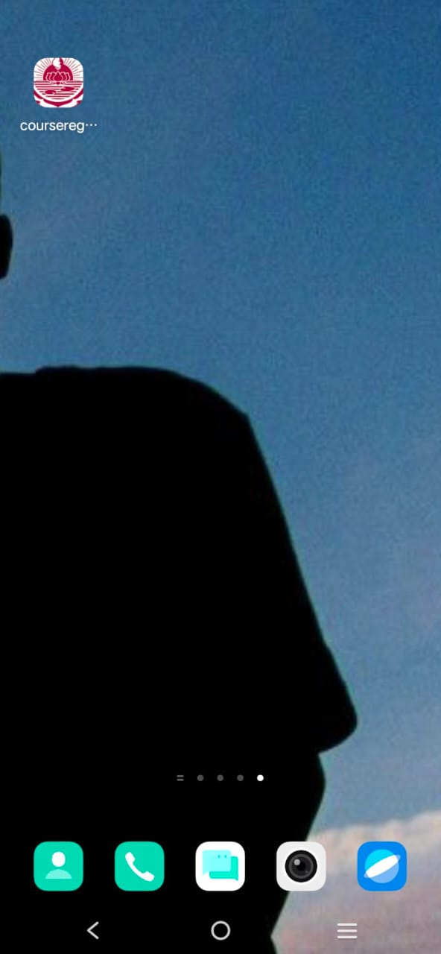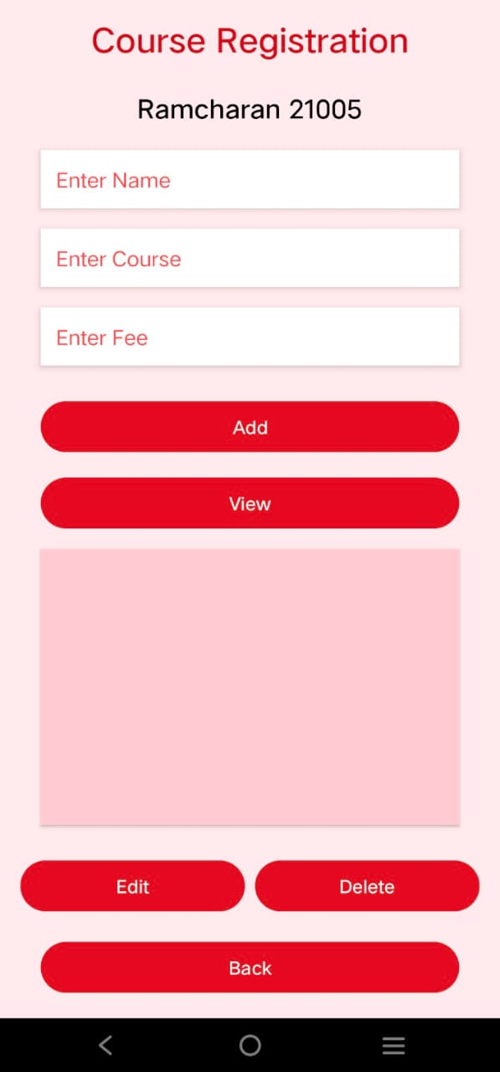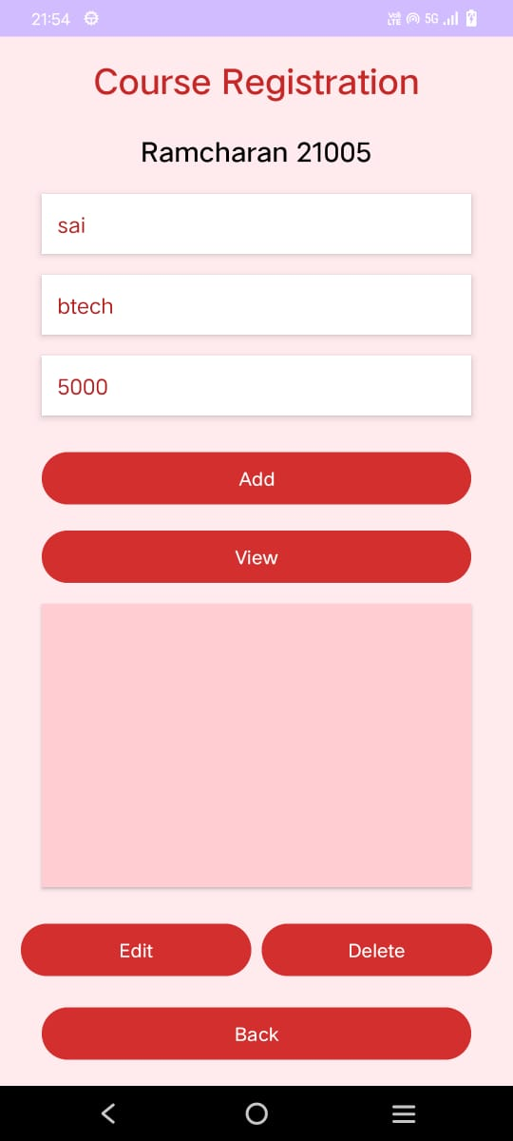

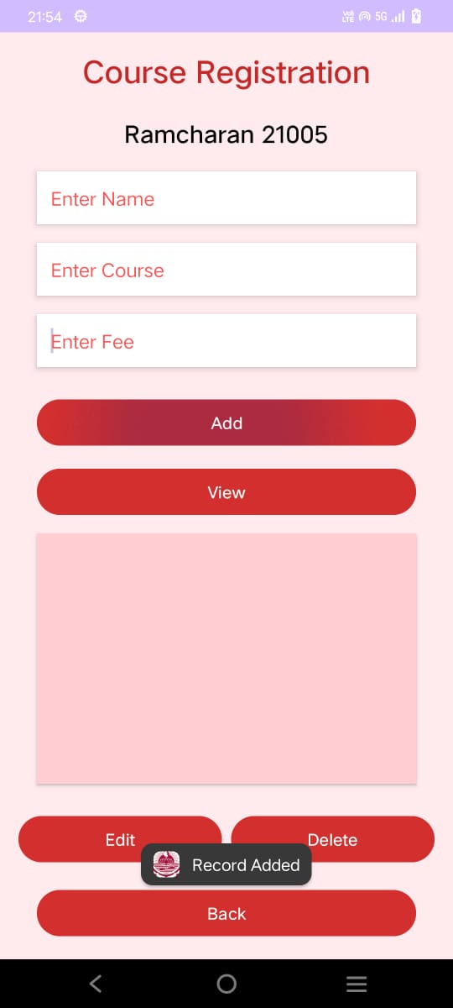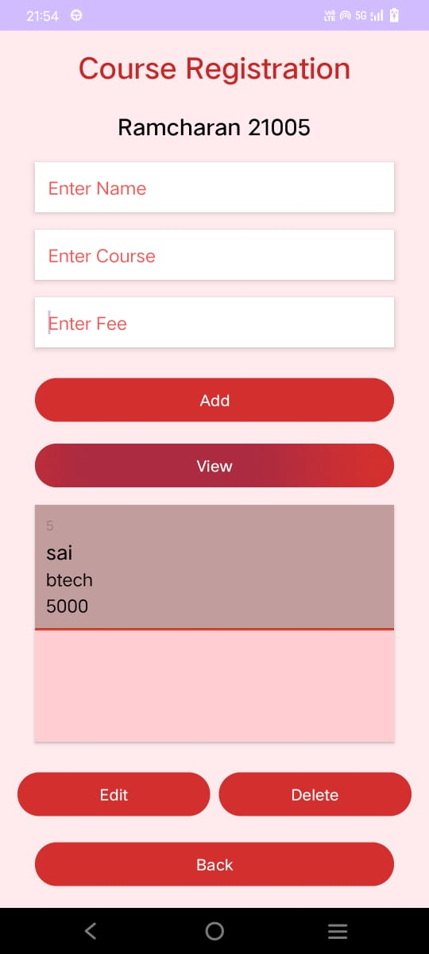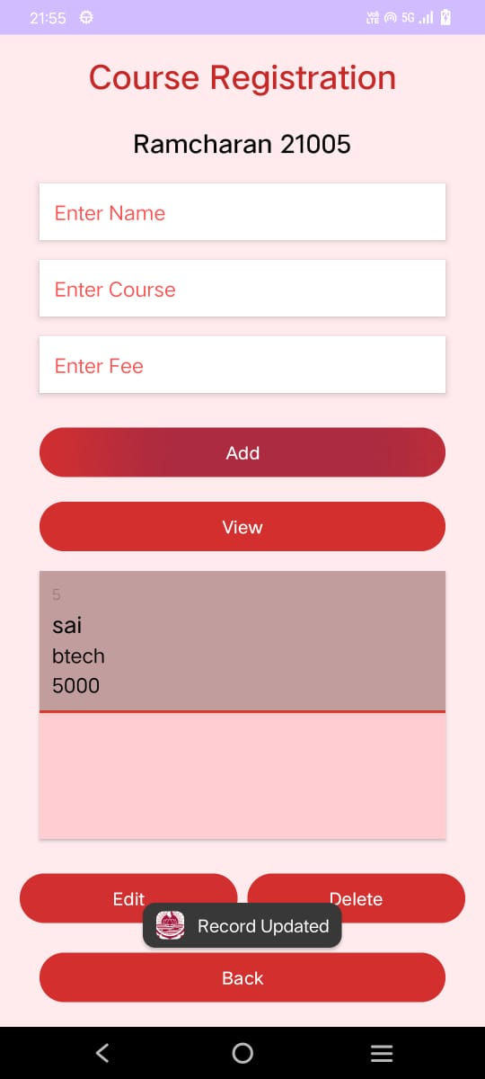

**Database in Sqlite:**

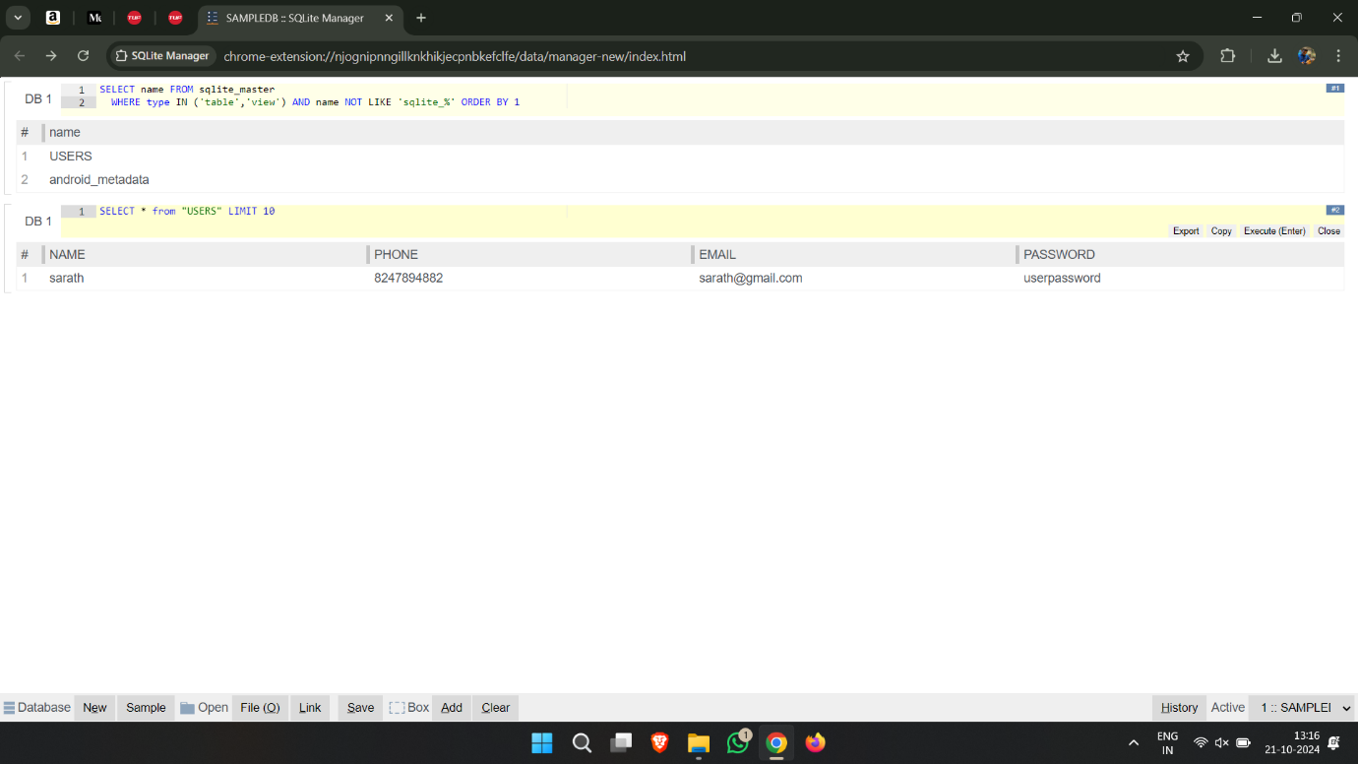

**Result :**

Created a course registration android app which is connected to database.